

Consent form – Interview
Title of Research Project: [Add title and add relevant image]


Please put your initials in one of the boxes for each statement

 | I have read / heard and understood the information sheet.  YES
 | I have been able to ask questions  YES NO
 | I know I can stop at any time and nobody will mind.  YES NO
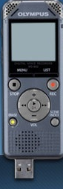 | I agree that the researcher can record our discussions or interviews.  YES NO
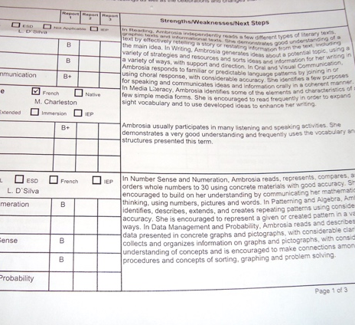 | The researcher will use my words from our conversation when writing their report but will not use my name or personal details.  YES NO
 | I know the researchers won’t tell anyone what I have said about the research but if I tell them I am going to hurt myself or anyone else then they will talk with (add as appropriate).  YES NO
 | I want to take part in this research  YES NO
IF RELEVANT ADD IMAGE HERE | [Add if applicable in group work etc) I know I can still join with the group for our usual meetings even if I do not take part in the research [add relevant image]  YES NO

Name of participant | Date | Signature
Name of researcher | Date | Signature

